Screenshots of the data

1. Array[10] Sorted and Unsorted(after ==End of Loop====)

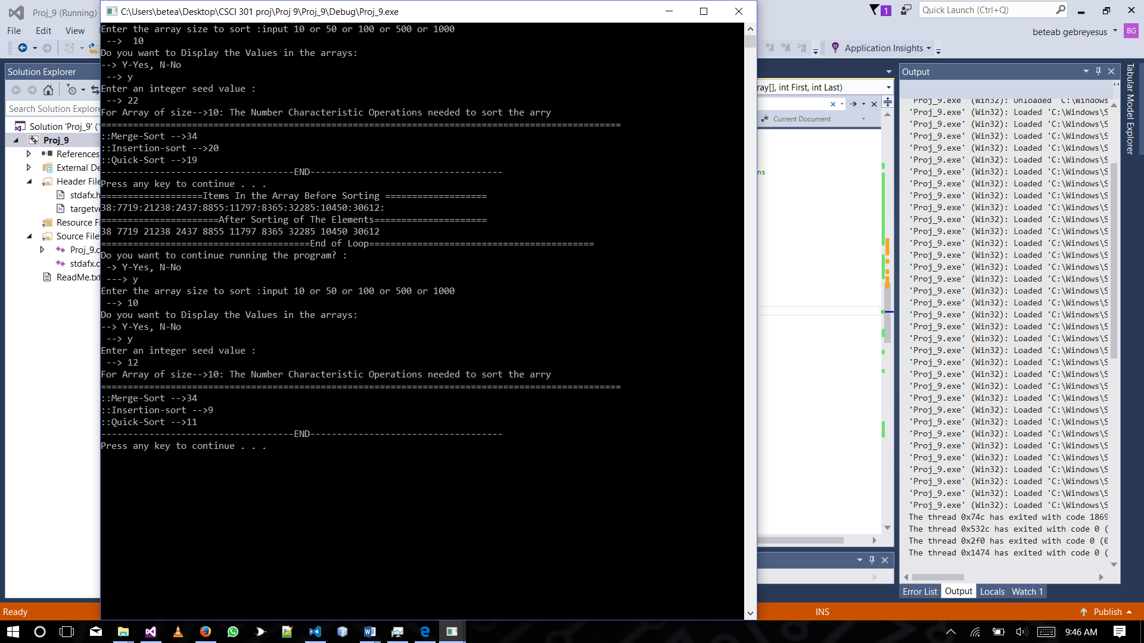

1. Array[50] Sorted and Unsorted(after ==End of Loop====)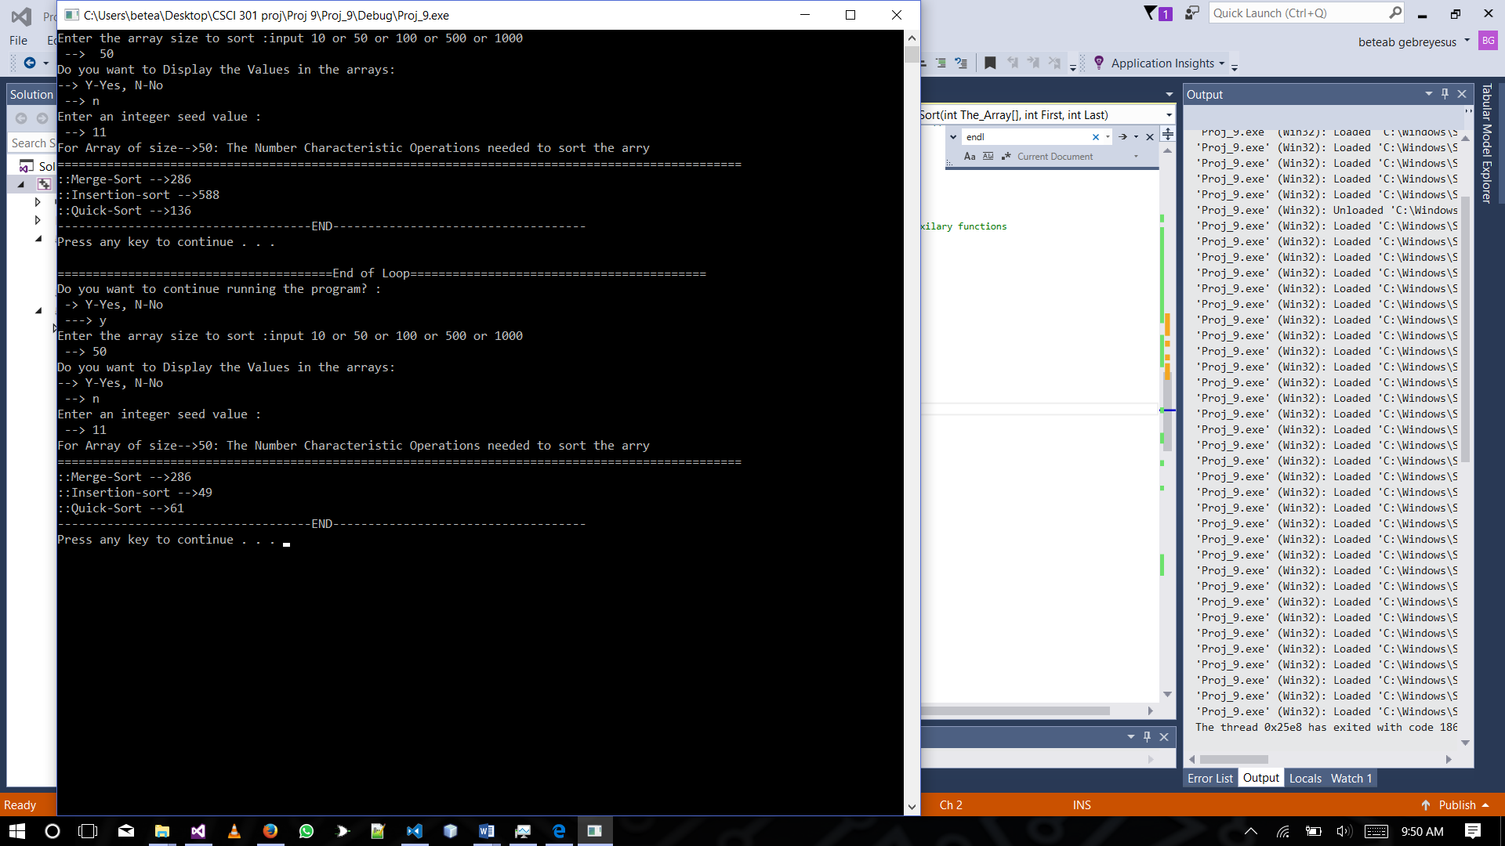
2. Array[100] Sorted and Unsorted(after ==End of Loop====)

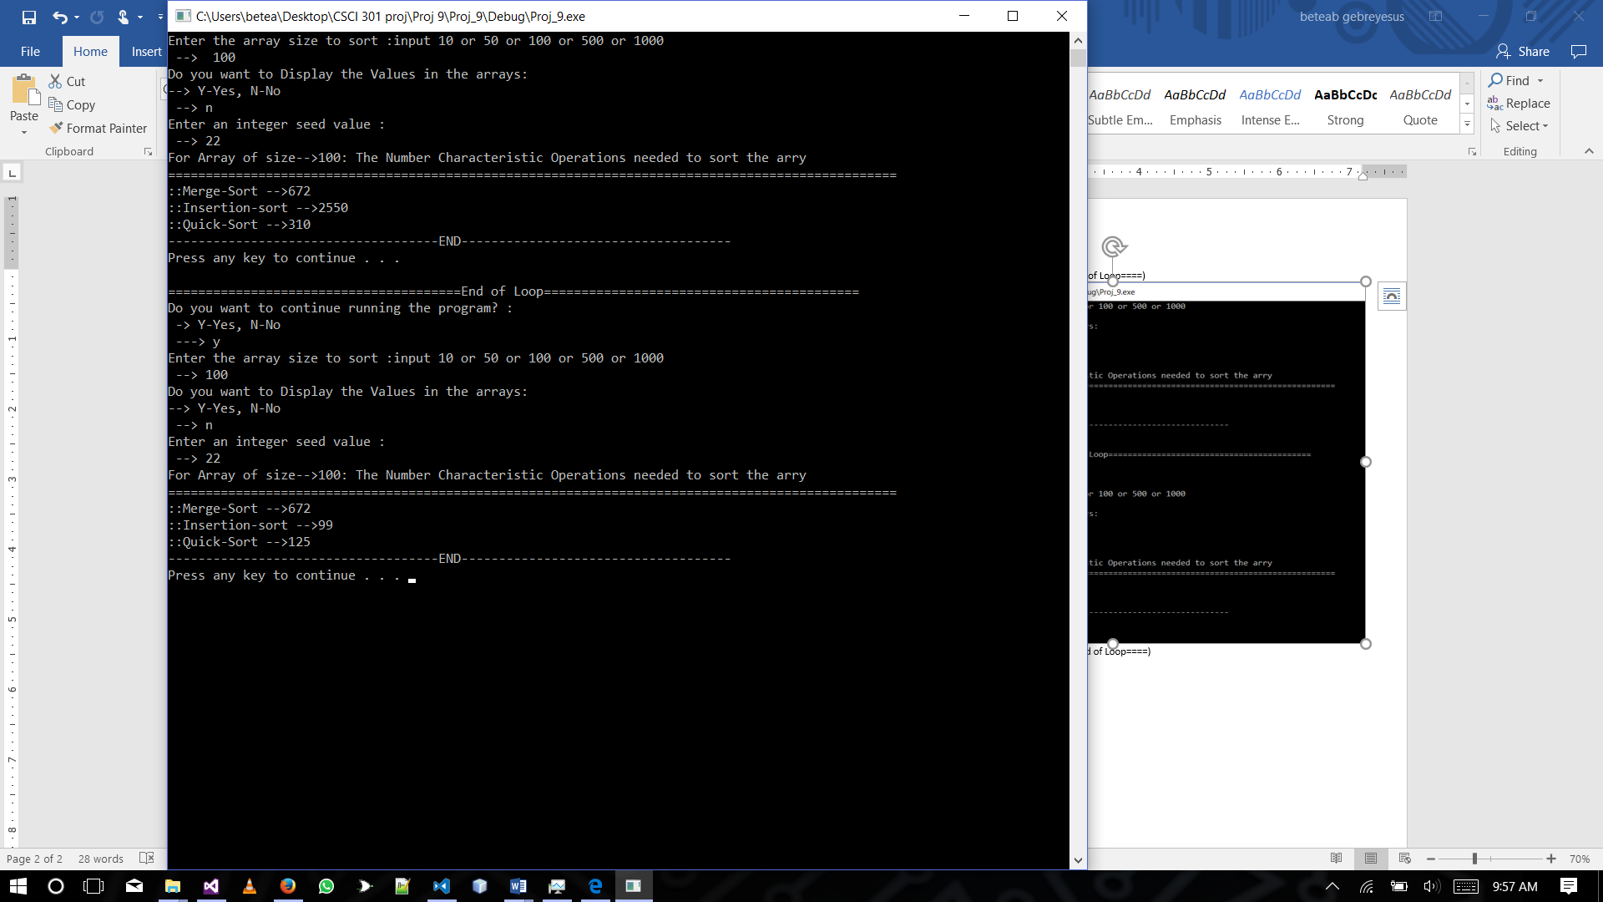

1. Array[500] Sorted and Unsorted(after ==End of Loop====)

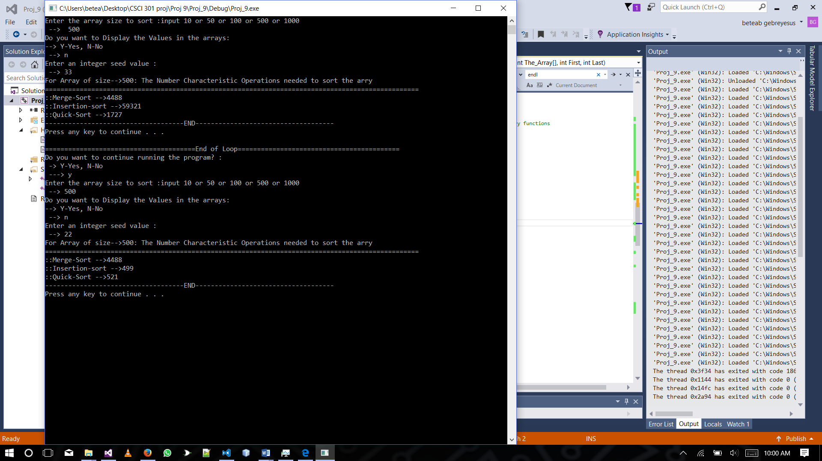

1. Array[1000] Sorted and Unsorted(after ==End of Loop====)

